MiSACWIS Project

CF14 – Maintain Task Approvals Screen Specification
Version 1.4

January 22, 2013

Prepared for:


120 N. Washington Square
SACWIS Project, 3rd Floor
Lansing, MI 48933

Prepared by:

Revision Log
Version | Date | A/D/C (Add, Delete, Change) | Author | Document Section # | Description
0.1 | 07/19/2011 |  | Matt McElver |  | Initial version
0.2 | 10/27/2011 | A | Mark Van Hoose | 3.1.5, 3.1.8 | Change Control 1093
1.0 | 12/01/2011 | C | Mark Van Hoose | All | Iteration 8 Approved
1.1 | 02/10/2012 | C | Mark Van Hoose | 3.1.2 | Change Control 2551
1.2 | 02/15/2012 | C | Mark Van Hoose | 3.1.2, 3.1.5 | Change Control 4674
1.3 | 03/14/2012 | A | Kelli Stone | 2.1.8, 3.1.5 | Began making changes required by change control 6340
1.4 | 03/21/2012 | A | Kelli Stone | 2.1.8, 3.1.5 | Completed changes for change control 6340.
1.5 | 01/22/2013 | C | Mark Van Hoose
Table of Contents
1 Introduction 5
1.1 Purpose 5
1.2 Scope 5
2 Use Case Details 6
2.1.1 Action Buttons/Hyperlinks 6
2.1.2 Business Rules 6
2.1.3 Security Requirements 6
2.1.4 Screen Navigation 6
2.1.5 Tab Order 7
2.1.6 Pre-Conditions 7
2.1.7 Ticklers 7
2.1.8 Notifications 7
2.1.9 Calendar 8
2.1.10 Reports 8
2.1.11 Notes and Assumptions 8
3 Screen Details 9
3.1 S01 – Process Approval Screen 9
3.1.1 As Is – Screen Mock Up 9
3.1.2 To Be – Screen Mock Up 10
3.1.3 Screen Fields 11
3.1.4 Action Buttons/Hyperlinks 17
3.1.5 Business Rules 17
3.1.6 Screen Navigation 22
3.1.7 Pre-Conditions 22
3.1.8 Reference Values 22
3.2 S02 – Pending Approval Screen 24
3.2.1 As Is – Screen Mock Up 24
3.2.2 To Be – Screen Mock Up 24
3.2.3 Screen Fields 25
3.2.4 Action Buttons/Hyperlinks 28
3.2.5 Business Rules 28
3.2.6 Screen Navigation 29
3.2.7 Pre-Conditions 29
3.2.8 Reference Values 29

List of Figures
Figure 1 – Process Approval Screen 9
Figure 2 – Process Approval Screen – Updated Screen 10
Figure 3 – Pending Approvals Screen 24
Figure 4 – Pending Approvals Screen – Updated Screen 24

Introduction

Purpose
The CF14 - Maintain Task Approvals use case deals with the routing of tasks to reviewers and approvers. It also deals with the various actions taken by those reviewers and approvers to make an approval decision on the task.

Scope
Among actions that can be taken on this screen are Route, Route to my Supervisor, Recall, Reroute, Return for Re-work, Task Reviewed and Route, Deny, Approve, Make Corrections, and Approve Corrections. When a user routes a task, they must search for a specific user to send the approval request. The Route to My Supervisor action automatically routes the task to the supervisor of the logged in user. The Recall action pulls the task back from the approval process. The Reroute action is used to send the approval request to another reviewer or approver. The Return for Re-work action is used by a reviewer or approver to send it back to the originator (See Section 3.1.9.1) of the approval request. The Deny and Approve actions are final actions that lock down the task from further editing. However a Correction Worker will be capable of re-opening the task for editing. Once those corrections are made the action of Approve Corrections can be made to lock down the task once more.

- Use Case Details

    - Action Buttons/Hyperlinks

Status (Keep/Add/Modify/Delete) | Label | Type | On Click Action/Navigation
 | N/A

    - Business Rules
No. | Status (Keep/Add/Modify/Delete) | Business Rule Description | Modified Business Rule Description | Execution Event (field tab out/save etc) | Error Msg Code  To be completed by Development Team
 | N/A
    - Security Requirements
No. | Status (Keep/Add/Modify/Delete) | Security Requirement
1 | Keep | Create  Worker has rights to Create
2 | Keep | Read  Worker has the rights to Read.
3 | Keep | Update  Worker has rights to Update
4 | Keep | Delete  N/A
    - Screen Navigation
No. | Status (Keep/Add/Modify/Delete) | To Screen Navigation Path
1 | Keep | This screen is accessed from the ‘Approval’ button from the calling Use Case.
2 | Keep | This screen is accessed from clicking on the recall/reroute hyperlink on the Pending Approval screen.
    - Tab Order
No. | Status (Keep/Add/Modify/Delete) | Screen name
N/A |  | N/A
    - Pre-Conditions
No. | Status (Keep/Add/Modify/Delete) | Pre-Condition
1 | Keep | Completed Task needing approval must exist and have passed all validations in MiSACWIS.
    - Ticklers
Status (Keep/Add/Modify/Delete) | Tickler Name | Trigger Action | Tickler Generation Business Rule & Description | Tickler Removal Business Rule | Tickler Text
Status (Keep/Add/Modify/Delete) | Tickler Role
 | N/A
    - Notifications
Status (Keep/Add/Modify/Delete) | Notification Name | Trigger Action | Message Business Rule & Description | Message Text
Status (Keep/Add/Modify/Delete) | Notification Role | Trigger Action | Message Business Rule & Description | Message Text
Add | Approval Action Taken | User clicks on the Save button and the Send Notification check box has been checked on the Process Approval screen and the action is any action other than 'Return for Rework' and 'Make corrections'. | The notification should be sent to the receiving employee of the appoval action for all actions except 'Return for Rework' and 'Make Corrections'. | <Name of Sending User> has taken the approval action of <Action> on the <Task Type> for the <Work-Item Type> # <Work-item ID> - <Work-item Reference>.
Add | The receiving user of an Approval Action.
Add | Returned Approval Action Taken | User clicks on the Save button and the Send Notification check box has been checked on the Process Approval screen and the action is 'Return for Rework' or 'Make Corrections'. | The notification should be sent to the originator of the appoval request for the actions of 'Return for Rework' or 'Make Corrections'. | <Name of Sending User> has returned a <Task Type> on the <Work-Item Type> # <Work-item ID> - <Work-item Reference> for the purposes of making changes or corrections. The following comments were left by <Name of Sending User> as to why this was returned to you: <Comments>. The due date for these changes is <Corrections Due Date>.
Add | The originator of the Approval request.
Add | Notification to Egregious Act Confirmer | IF on CF14 S01 in the “Action” dropdown list the user selects “Approve”  and  IF on IV13 S01, the user selects “Yes” in the “Egregious” dropdown list  And  IF on CF14 S01 the user selects “Save” | Send the notification to users with the assigned role of Egregious Act Confirmer  IF on CF14 S01 in the “Action” dropdown list the user selects “Approve”  and  IF on IV13 S01, the user selects “Yes” in the “Egregious” dropdown list  And  IF on CF14 S01 the user selects “Save” | Investigation <Investigation Name> <Investigation Number> was approved by <Approver>. This investigation contains an egregious act. Please assess perpetrator(s) for potential Protective Service Alert.
Add | Egregious Act Confirmer
    - Calendar
Status (Keep/Add/Modify/Delete) | Calendar Name | Trigger Action | Calendar Event Generation Business Rule & Description | Calendar Event Date and Time Business Rule | Calendar Event Text
Status (Keep/Add/Modify/Delete) | Calendar Role
 | N/A
    - Reports
N/A
    - Notes and Assumptions
N/A

Screen Details

S01 – Process Approval Screen

As Is – Screen Mock Up

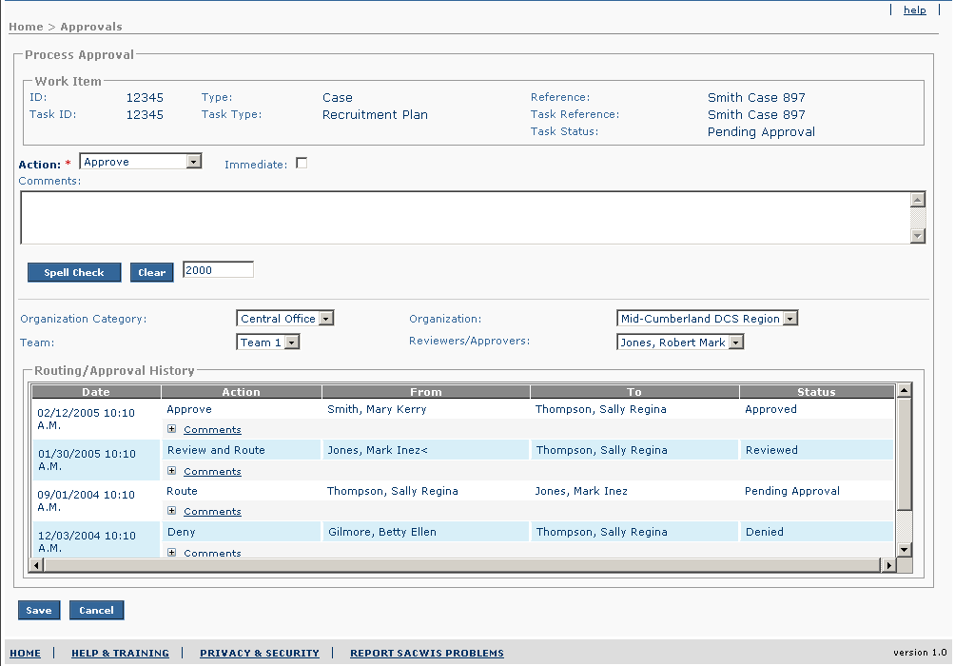
Figure 1 – Process Approval Screen

To Be – Screen Mock Up
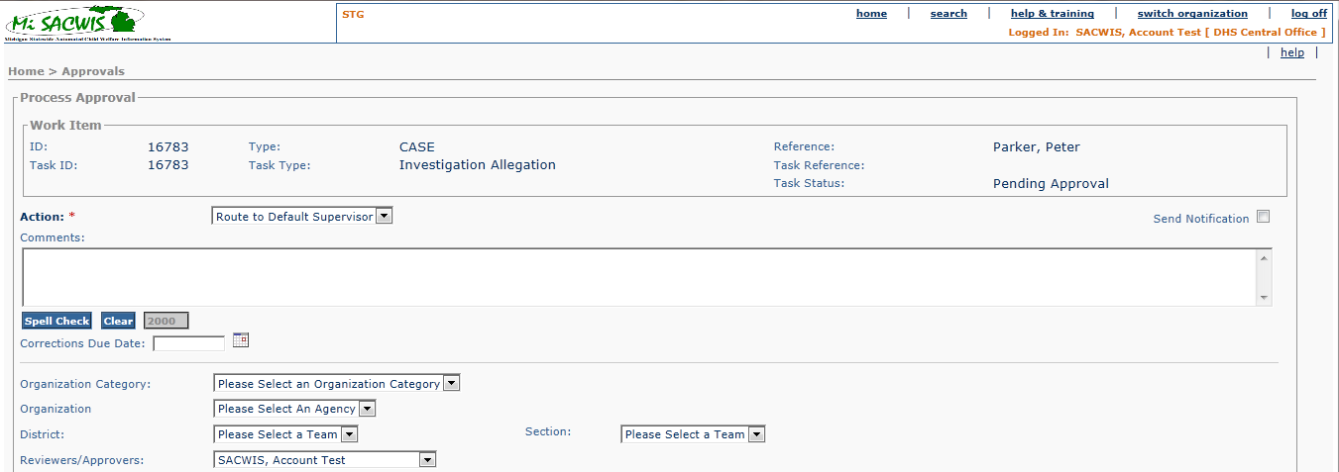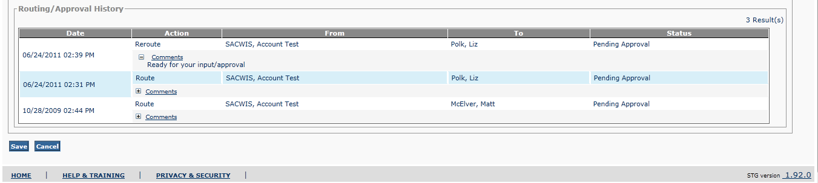
Figure 2 – Process Approval Screen – Updated Screen

Screen Fields
Status (Keep/Add/Modify/Delete) | As Is  Class.Attribute Name | To Be  Class.Attribute Name | As Is  Display Name | To Be  Display Name | To Be  Type | To Be  Align | To Be Size | To Be  Read  Only | To Be  Calculation | To Be  Edit Mask | To Be  UI Validation
Keep | N/A | N/A | Process Approval | Process Approval | Section Header | L | N/A | T
Keep | N/A | N/A | Work Item | Work Item | Section Header | L | N/A | T
Keep | WorkLoadItem.WorkItemId | WorkLoadItem.WorkItemId | ID: | ID: | Display Text | L | 22 | T
Keep | WorkLoadItem.WorkItemTypeCode | WorkLoadItem.WorkItemTypeCode | Type: | Type: | Display Text | L | 30 | T
Keep | WorkLoadItem.WorkItemReference | WorkLoadItem.WorkItemReference | Reference: | Reference: | Display Text | L | 300 | T
Keep | RoutedTaskHistory.taskTypeCode | RoutedTaskHistory.taskTypeCode | Task ID: | Task ID: | Display Text | L | 30 | T
Keep | RoutedTaskHistory.taskTypeCode | RoutedTaskHistory.taskTypeCode | Task Type: | Task Type: | Display Text | L | 30 | T
Keep | RoutedTaskHistory.taskReference | RoutedTaskHistory.taskReference | Task Reference: | Task Reference: | Display Text | L | 40 | T
Keep | RoutedTaskHistory.taskStatusCode | RoutedTaskHistory.taskStatusCode | Task Status: | Task Status: | Display Text | L | 30 | T
Keep | RoutedTaskHistory.taskActionCode | RoutedTaskHistory.taskActionCode | Action: | Action: | Drop Down List | L | 30 | T | See BRs & 3.1.9.2 for how to populate |  | Required Field
Modify | RoutedTaskHistory.immediateFlag | RoutedTaskHistory.immediateFlag | Immediate | Send Notification | Check Box | L | N/A | F |  |  | Indicates if certain notifications need to be sent.  Default Checked
Keep | RoutedTaskHistory.commentsText | RoutedTaskHistory.commentsText | Comments: | Comments: | Text Field | L | 2000 | F |  |  | Conditionally required for “Deny” and “Return for Rework” actions.
Add | N/A | N/A | N/A | Corrections Due Date | Date Field | L | 10 | F |  | MM/DD/YYYY | Used to populate the 'Approval Action Taken' notification.
Keep | Agency.agencyCategoryCode | Agency.agencyCategoryCode | Organization Category | Organization Category | Drop Down List | L | 100 | F |  |  | Default will be the Organization Category that matches the supervisor of the logged in user.  Grayed out based upon BR 3.1.5.20 & 3.1.5.23
Keep | Agency.agencyName | Agency.agencyName | Organization | Organization | Drop Down List | L | 100 | F |  |  | Default will be the Organization of the logged in user.  Grayed out based upon BR 3.1.5.20 & 3.1.5.23
Delete | AgencyUnit.agencyUnitName | AgencyUnit.agencyUnitName | Team | Team | Drop Down List | L | 50 | F |  |  | Default will be the Team of the logged in user.  The List of Teams for the selected Organization.  Grayed out based upon BR 3.1.5.20 & 3.1.5.23
Add | N/A | AgencyUnit.district | N/A | District | Drop Down List | L | 100 | F |  |  | Grayed out based upon BR 3.1.5.20 & 3.1.5.23
Add | N/A | AgencyUnit.section | N/A | Section | Drop Down List | L | 100 | F |  |  | Grayed out based upon BR 3.1.5.20 & 3.1.5.23
Keep | Employee.employeeId  Person.lastName  Person.firstName  Person.middleName | Employee.employeeId  Person.lastName  Person.firstName  Person.middleName | Reviewer/Approver | Reviewer/Approver | Drop Down List | L | 100 | F |  | (last name, first name, middle name) | All users with Reviewer or Approver security for the selected Team and selected task.  Grayed out based upon BR 3.1.5.20 & 3.1.5.23
Keep | N/A | N/A | Routing/Approval History | Routing/Approval History | Section Header | L | N/A
Keep | RoutedTaskHistory.statusDate | RoutedTaskHistory.statusDate | Date | Date | Display Text | L | 10 | T |  | mm/dd/yyyy hh:mm AM/PM | Note: Sorted in descending order of the date
Keep | RoutedTaskHistory.taskActionCode | RoutedTaskHistory.taskActionCode | Action | Action | Display Text | L | 30 | T
Keep | Person.lastName + Person.firstName + Person.middleName | Person.lastName + + Person.suffixCode + Person.firstName + Person.middleName | From | From | Display Text | L | 100 | T |  | Last Name, Suffix Code, First Name  Middle Name | Derived from the Requesting Employee ID
Keep | Person.lastName + Person.firstName + Person.middleName | Person.lastName + + Person.suffixCode + Person.firstName + Person.middleName | To | To | Display Text | L | 100 | T |  | Last Name, Suffix Code, First Name  Middle Name | Derived from the Receiving Employee ID
Keep | RoutedTaskHistory.taskStatusCode | RoutedTaskHistory.taskStatusCode | Status | Status | Display Text | L | 30 | T
Keep | RoutedTaskHistory.commentsText | RoutedTaskHistory.commentsText | Comments | Comments | Display Text | L | 2000 | T

Action Buttons/Hyperlinks
Status (Keep/Add/Modify/Delete) | Label | Type | On Click Action/Navigation
Keep | Comments | Expando | Opens the Comments for the User to be able to view.
Keep | Save | Button | System saves the data. Returns to calling screen. Used in edit mode.
Keep | Cancel | Button | Returns the user back to the calling screen without saving changes. Used in edit mode.
Keep | Close | Button | Returns the user back to the calling screen. Used for Read-only mode.

Business Rules
No. | Status (Keep/Add/Modify/Delete) | Business Rule Description | Modified Business Rule Description | Execution Event (field tab out/save etc) | Error Msg Code  To be completed by Development Team
1 | Keep | Originator of an approval request cannot review or approve the task if a “Uniqueness” flag is true in the database for a given task type. If the Uniqueness flag exists for a task, only the actions ‘Route’, ‘Reroute’, 'Route to my Supervisor' and ‘Recall’ will be available in the Actions drop down field for the Originator of the Approval Request regardless of the Originator’s security . |  | Action drop down field
2 | N/A | Previously Deleted BR | N/A | N/A
3 | Keep | If the action selected is ‘Deny’, the user must enter a comment and the system will confirm that the user really wants to deny the task. |  | Selecting the “Deny” Action and clicking on Save. The System will ask “Denying this task will prevent any further editing of it. Are you sure that you want to deny this task? OK/Cancel”
4 | N/A | Previously Deleted BR | N/A | N/A
5 | Keep | If a “Uniqueness” flag is true in the database for a given task type, the Originator, each reviewer, and the approver must all be different employees whenever the action ‘route’, ‘task reviewed and route’, and ‘approve’ is selected. |  | Save Button
6 | Keep | If a user does not select a valid Reviewer/Approver and one is required (i.e. ‘Recall’, ‘Approve’, ‘Deny’, or ‘Return for Rework’ actions haven’t been selected) the system will not save. |  | Save Button
7 | Keep | A task cannot be re-routed to the same Reviewer/Approver (new destination cannot be the same as the last destination). |  | Save Button
8 | Keep | Task can only be routed to one person at a time for review/approval. |  | N/A
9 | Modify | All Reviewers/Approvers in a Team need to be listed in the drop down (include self, if Approver). | The Reviewers/Approvers come from all users that have security to review or approve and meet the user selected filters of Organization Category, Organiztion, District and Section. A user must select Organization Category and Organization at a minimum before the Reviewers/Approvers drop down begins to populate. District and Section are optional filter criteria for the Reviewers/Approvers field. | Population of Reviewer/Approver Drop Down List
10 | Keep | Every task at any given point in time has only one current task status. |  | N/A
11 | Keep | Any review/approval decision once rendered cannot be retracted. |  | N/A
12 | Keep | A review/approval decision can only be rendered by the person to whom the task has been routed to or his or her delegate. |  | ‘Approval’ button on calling use case.
13 | Keep | There can be more than one reviewer for any task and the review can be performed at any point before Final Approval. |  | N/A
14 | Keep | The Final Approval can be rendered only by a person who has the role of Supervisor specified by the business process. |  | Action drop down field
15 | Keep | The Reviewer does not have the option to render the final approval, but has the following options to choose from: “Task Reviewed and Route”, “Return for Rework”, or “Deny”. |  | Action drop down field
16 | Keep | The Final Approver has the following options to choose from “Approve”, “Deny” and “Return for Re-work”. |  | Action drop down field
17 | Keep | If a person has any combination of the Reviewer, Intermediate Approver or the Final Approver roles, the options available to that person will be a combination from the corresponding roles. |  | Action drop down field
18 | Keep | When a Reviewer or an Approver selects the option: “Return for Rework”, the System changes the status of the task to “In Progress” |  | Save Button
19 | Delete | When the “Deny” “or “Approve” “option is selected that decision constitutes a final irrevocable decision and the approval process for the corresponding task cannot be restarted. |  | Save Button
20 | Modify | When user selects the ‘Route to My Supervisor’ action from the Action dropdown, the following fields should be disabled (grayed out): Organization Category, Organization, Team, and Reviewers/Approvers. Also the supervisor of the logged in user should appear in the Reviewer/Approver field | When user selects the ‘Route to My Supervisor’ action from the Action dropdown, the following fields should be disabled (grayed out): Organization Category, Organization, Distict, Section, and Reviewers/Approvers. Also the supervisor of the logged in user should appear in the Reviewer/Approver field | User selects the ‘Route to My Supervisor’ action from the Action dropdown
21 | Keep | Upon successfully saving with the ‘Route to My Supervisor’ action selected the system should route the pending approval to the supervisor of the logged in user. |  | Save Button
22 | Keep | If the Recall/Reroute hyperlink is clicked on from the Pending Approval screen then only Recall and Reroute will display in the action drop down fields. |  | Population of the Action Drop Down List.
23 | Modify | The Organization Category, Organization, Team, and Reviewer/Approver fields will be null and disabled if the ‘Recall’, ‘Approve’, ‘Deny’, or ‘Return for Rework’ actions are selected. | The Organization Category, Organization, Disctict, Section and Reviewer/Approver fields will be null and disabled if the ‘Recall’, ‘Approve’, ‘Deny’, ‘Return for Rework’ , 'Make Corrections' or 'Approve Corrections' actions are selected.
24 | Add | The Action of "Approve Corrections" will only be available to the user with Supervisor security when the task has been unlocked previously to make corrections. |  | Population of the Action Drop Down List.
25 | Add | The actions of "Approve" and "Deny" will not be available if the task has previously been in either the 'Approved' or 'Denied' status. |  | Population of the Action Drop Down List.
26 | Add | When the user selects and saves the "Approve Corrections" action, the task should be frozen once more. |  | Save Button
27 | Add | If the user selects the "Approve Corrections" action, the comments must be entered. |  | Save Button
28 | Add | The Approval Due Date column of the Routed Task History table is calculated on the initial save of the first approval action taken per task. The calculation is done by taking the System Date and adding the number of days stored in the short description column of the Ref Data table where the domain code = 'ApprovalDueDate' and the Parent Reference Data Code is the same as the task type code of the task being approved. On all subsequent approval actions for a task, the calculated value of the Approval Due Date should be copied to the newly created row in the Routed Task History table. |  | Save Button
29 | Add | When a user selects the "Return for Rework" or "Make Corrections" action the user must have the Send Notification check box checked. |  | Save Button
30 | Add | The Organization drop down will be populated in alphabetical order with all active Organizations stored in the Agency table that correspond to the user selected Organization Category. |  | Population of the Organization Drop Down List
31 | Add | The Action of "Make Corrections" will only appear and be the only available action when the logged-in user is a Correction Worker and when the status of a task is either "Approved" or "Approved - Corrected Work". |  | Population of the Action Drop Down List.
32 | Add | IF on CF14 S01 in the “Action” dropdown list the user selects “Approve”  and  IF on IV13 S01, the user selects “Yes” in the “Egregious” dropdown list  And  IF on CF14 S01 the user selects “Save”  Then  Display a pop up window that says “A preponderance of evidence has been found for an egregious act in this investigation. If the investigation is approved, a notification will be sent to DHS Central Office for confirmation.” |  | Save Button

Screen Navigation
No. | Status (Keep/Add/Modify/Delete) | To Screen Navigation Path
1 | Keep | This screen is accessed from the ‘Approval’ button from the calling Use Case.
2 | Keep | This screen is accessed from clicking on the recall/reroute hyperlink on the Pending Approval screen.

Pre-Conditions
No. | Status (Keep/Add/Modify/Delete) | Pre-Condition
1 | N/A | N/A
    - Reference Values
No. | Status (Keep/Add/Modify/Delete) | To Be Class Attribute | Domain Code | Short Desc | Ref Data Code
1 | Add | AgencyUnit.district | District | Not Yet Provided by the State.
2 | Add | AgencyUnit.section | Section | Not Yet Provided by the State.
3 | Add | RoutedTaskHistory.statusDate | ApprovalDueDate | Not Yet Determined
4 | Modify | Agency.agencyCategoryCode | AgencyCategory | Central Intake | CENTRALINTAKEORG
 |  |  |  | Central Office | CENTRALOFFICEORG
 |  |  |  | DHS Residential | DHSRESIDENTIAL
 |  |  |  | DHS County Office | DHSCOUNTY OFFICE
 |  |  |  | Other | OTHER
 |  |  |  | Other State Agency | OTHERSTATEORG
 |  |  |  | Court | COURT
 |  |  |  | Private Agency | PRIVATEAGENCY
 |  |  |  | Tribe | TRIBE
5 | Modify | RoutedTaskHistory.taskActionCode | TaskActionCode | Route | ROUTE
 |  |  |  | Route to My Supervisor | RTDS
 |  |  |  | Recall | RC
 |  |  |  | Reroute | REROUTE
 |  |  |  | Return for Re-work | DRW
 |  |  |  | Task Reviewed and Route | RVWR
 |  |  |  | Recall | RC
 |  |  |  | Deny | D
 |  |  |  | Approve | AF
 |  |  |  | Make Corrections | MAKECORRECTIONS
 |  |  |  | Approve Corrections | APPROVECORRECTIONS
6 | Modify | RoutedTaskHistory.taskStatusCode | TaskStatusCode | Approved | A
 |  |  |  | Denied | D
 |  |  |  | In Progress | IP
 |  |  |  | Pending Approval | PA
 |  |  |  | Approved - Corrected Work | APPROVEDCORRECTEDWORK

    - Approval Notes and Assumptions
- The means of determining the “originator” of an approval request will be looking through the Routed Task History table for the most recent time the status was “In Progress” then looking for the ‘From’ employee.
- The following is a chart that demonstrates how the status and actions behave in all possible approval scenarios:
Approval Scenarios | Action | Status
When a worker (Originator) chooses to send the task to be reviewed or approved by a reviewer or approver. | The Action of that task is user selected to be 'Route' | The status of that task will be set to 'Pending Approval'
When a worker (Originator) chooses to send the task to be reviewed or approved by his or her direct supervisor. | The Action of that task is user selected to be 'Route to My Supervisor' | The status of that task will be set to 'Pending Approval'
When the Worker (Originator) chooses to recall the task | The Action of that task is user selected to be 'Recall' | The status of that task will be set to 'In Progress'
When the Originator/Reviewer/Approver chooses to re-route the task | The Action of that task is user selected to be 'Reroute' | The status of that task will remain as 'Pending Approval’
When the reviewer/approver chooses to return the routed task back to the originator | The Action of that task is user selected to be 'Return for Re-work'. | The status of that task will be set to 'In Progress'
When a reviewer wants to indicate that they have reviewed a record and wants to route the task on for another layer of approval. | The Action of that task is user selected to be 'Task Reviewed and Route' | The status of that task will remain as ‘Pending Approval’
When an Approver chooses to make the permanent decision to deny the task making the task uneditable. | The Action of that task is user selected to be 'Deny' | The status of that task will be set to 'Denied'
When an approver chooses the “Approve” option | The Action of that task is user selected to be 'Approve' | The status of that task will be set to 'Approved'
When a correction worker chooses to open up a task so that corrections can be made. | The Action of that task is user selected to be 'Make Corrections' | The status of that task will be set to 'In Progress'
When an Approver is ready to accept the corrections to an approved piece of work. | The Action of that task is user selected to be 'Approve Corrections' | The status of that task will be set to 'Approved - Corrected Work'
- The Uniqueness flag are master reference values stored only in the code. There is no means in the application to change these fields. They can only be modified by a developer.

S02 – Pending Approval Screen

As Is – Screen Mock Up
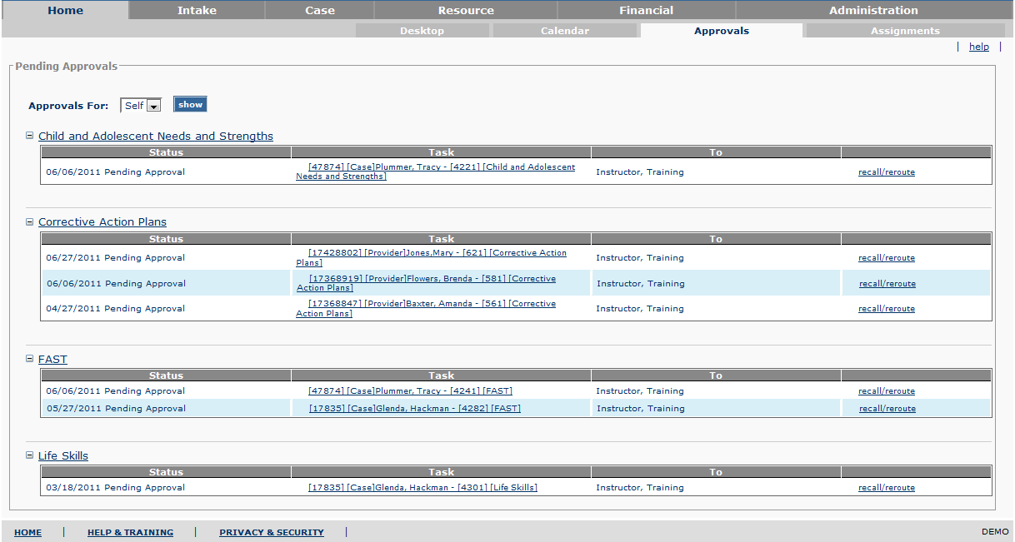
Figure 3 – Pending Approvals Screen

To Be – Screen Mock Up
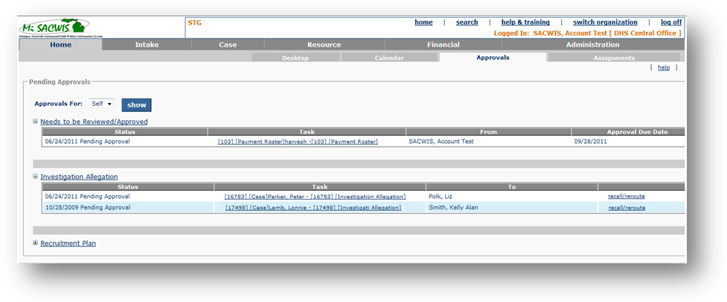
Figure 4 – Pending Approvals Screen – Updated Screen

Screen Fields
Status Keep/Add/Modify/Delete) | As Is  Class.Attribute Name | To Be  Class.Attribute Name | As Is  Display Name | To Be  Display Name | To Be  Type | To Be  Align | To Be Size | To Be  Read  Only | To Be  Calculation | To Be  Edit Mask | To Be  UI Validation
Keep | N/A | N/A | Pending Approvals | Pending Approvals | Section Header | L | N/A | T
Keep | Person.lastName + Person.firstName + Person.middleName | Person.lastName + Person.suffixCode + Person.firstName + Person.middleName | Approvals for: | Approvals for: | Drop Down List | L | 100 | F |  |  | Default value is 'Self'.  Populates with the list of employees that have delegated authority to the user using Use Case CF34 and ‘self’.
Keep | RoutedTaskHistory.statusDate  RoutedTaskHistory.taskStatusCode | RoutedTaskHistory.statusDate  RoutedTaskHistory.taskStatusCode | Status | Status | Display Text | L | 40 | T |  | mm/dd/yyyy (for date) | Note: Sort by ascending order of the status date.
Keep | WorkLoadItem.WorkItemId  WorkLoadItem.WorkItemTypeCode  WorkLoadItem.WorkItemReference  RoutedTaskHistory.task_Id  RoutedTaskHistory.taskTypeCode | WorkLoadItem.WorkItemId  WorkLoadItem.WorkItemTypeCode  WorkLoadItem.WorkItemReference  RoutedTaskHistory.task_Id  RoutedTaskHistory.taskTypeCode | Task | Task | Text Field | L | 352 | T
Keep | Person.lastName, + Person.firstname | Person.lastName, + Person.firstname | To | To | Text Field | L | 100 | T |  | Last Name, First Name | Displays to whom the approval request was sent.  This column is used for all expandos except the “Needs to be Reviewed/Approved” expando.  Employee Details from RoutedTaskHistory.receivingEmployeeId
Keep | Person.lastName, + Person.firstname | Person.lastName, + Person.firstname | From | From | Text Field | L | 100 | T |  | Last Name, First Name | Displays who the approval was sent from.  This column is used only for the “Needs to be Reviewed/Approved” expando.  Employee Details from RoutedTaskHistory.employeeId
Add | N/A | RoutedTaskHistory.statusDate | N/A | Approval Due Date | Date Field | L | 10 | T |  | MM/DD/YYYY

Action Buttons/Hyperlinks
Status (Keep/Add/Modify/Delete) | Label | Type | On Click Action/Navigation
Modify | Needs to be Reviewed/Approved | Expando | Displays all appoval requests sent to logged in user (or delegate).
Keep | <Task Type> | Expando | Displays all appoval requests sent by logged in user (or delegate).
Keep | Task | Hyperlink | Opens the corresponding work item task page
Keep | Recall/Reroute | Hyperlink | Takes a user to the Process Approval screen.  Displays next to a task based on business rules.
Keep | Show | Button | Displays the pending approval page for the selected employee in the ‘Approvals for:’ field.

Business Rules
No. | Status (Keep/Add/Modify/Delete) | Business Rule Description | Modified Business Rule Description | Execution Event (field tab out/save etc) | Error Msg Code  To be completed by Development Team
1 | Keep | The task approval request is listed on originator’s pending approvals page until a decision of “Approved” or “Denied” is rendered. |  | Loading the pending approval screen
2 | Keep | The task approval request is listed on a reviewer/approver’s pending approvals page until a decision is rendered by the person next on the approval chain. |  | Loading the pending approval screen
3 | Keep | Tasks can only be recalled/re-routed, as long as the person, to whom the task was routed, has not made an approval decision. |  | The recall/re-route hyperlink displaying on screen
4 | Modify | The expando title bars on this screen appear and disappear depending on what is contained in the Routed Task History table for the user. If there are any pending approvals that have the user as the receiving employee, the system will display an expando title bar titled ‘Needs Review/Approval’ and have these pending approvals under this expando. All other pending approvals will display under a title bar with the name of the task type that is pending approval. | The expando title bars on this screen appear and disappear depending on what is contained in the Routed Task History table for the user. If there are any pending approvals that have the user as the receiving employee, the system will display an expando title bar titled ‘Needs to be Reviewed/Approved’ and have these pending approvals under this expando. All other pending approvals will display under a title bar with the name of the task type that is pending approval. | Loading the pending approval screen
5 | Keep | All tasks in an “In Progress” status will not display on the Approval screen. |  | Loading the pending approval screen
6 | Add | All tasks in the 'Approved - Corrected Work' status will not display on the Approval screen. |  | Loading the pending approval screen
    - Screen Navigation
No. | Status (Keep/Add/Modify/Delete) | To Screen Navigation Path
1 | Keep | This screen is accessed through the ‘Approvals’ tab on the Home screen.

Pre-Conditions
No. | Status (Keep/Add/Modify/Delete) | Pre-Condition
1 | N/A | N/A

Reference Values
No. | Status (Keep/Add/Modify/Delete) | To Be Class Attribute | Domain Code | Short Desc | Ref Data Code
1 | N/A

Notes and Assumptions

None

